Task On kubernetes-1
- Setup Minikube in your local machine.

System Requirements
Make sure your laptop has:
- Windows 10/11 (64-bit)
- 4 GB RAM (minimum, 8 GB recommended)
- Virtualization enabled (BIOS)

Install Container Driver (Docker)
Install 👉 Docker Desktop

Steps:
- Download & install Docker Desktop
- During install:
  - Enable WSL2
- Start Docker
- Ensure status = Running

3. Install kubectl
Open PowerShell (Run as Administrator):
Invoke-WebRequest -Uri "https://dl.k8s.io/release/v1.30.0/bin/windows/amd64/kubectl.exe" -OutFile "kubectl.exe"

mkdir C:\k8s
move kubectl.exe C:\k8s\
Add C:\k8s to Environment Variables → PATH
Verify:
kubectl version --client

4. Install Minikube (PowerShell Correct Way)

🔹 Download Minikube
Invoke-WebRequest -Uri "https://storage.googleapis.com/minikube/releases/latest/minikube-windows-amd64.exe" -OutFile "minikube.exe"

🔹 Move it to your folder
move minikube.exe C:\k8s\

🔹 Verify Installation
minikube version

Start Minikube:
minikube start --driver=docker

Access Application in Browser (Minikube)

🔹 Step 1: Run Your App (if not already)
kubectl create deployment hello-minikube --image=kicbase/echo-server:1.0
kubectl expose deployment hello-minikube --type=NodePort --port=8080

🔹 Step 2: Open in Browser (Easiest Way)
minikube service hello-minikube
👉 What happens:
- Automatically finds the service URL
- Opens browser for you

👉 Copy this URL → paste in browser

Step 1: Check Pods
Run:
kubectl get pods

Step 2: Try Again
minikube service hello-minikube

Direct URL (Your Case)
You got:
http://192.168.49.2:32058

Final Working Flow
kubectl get pods
kubectl get svc
minikube service hello-minikube --ur

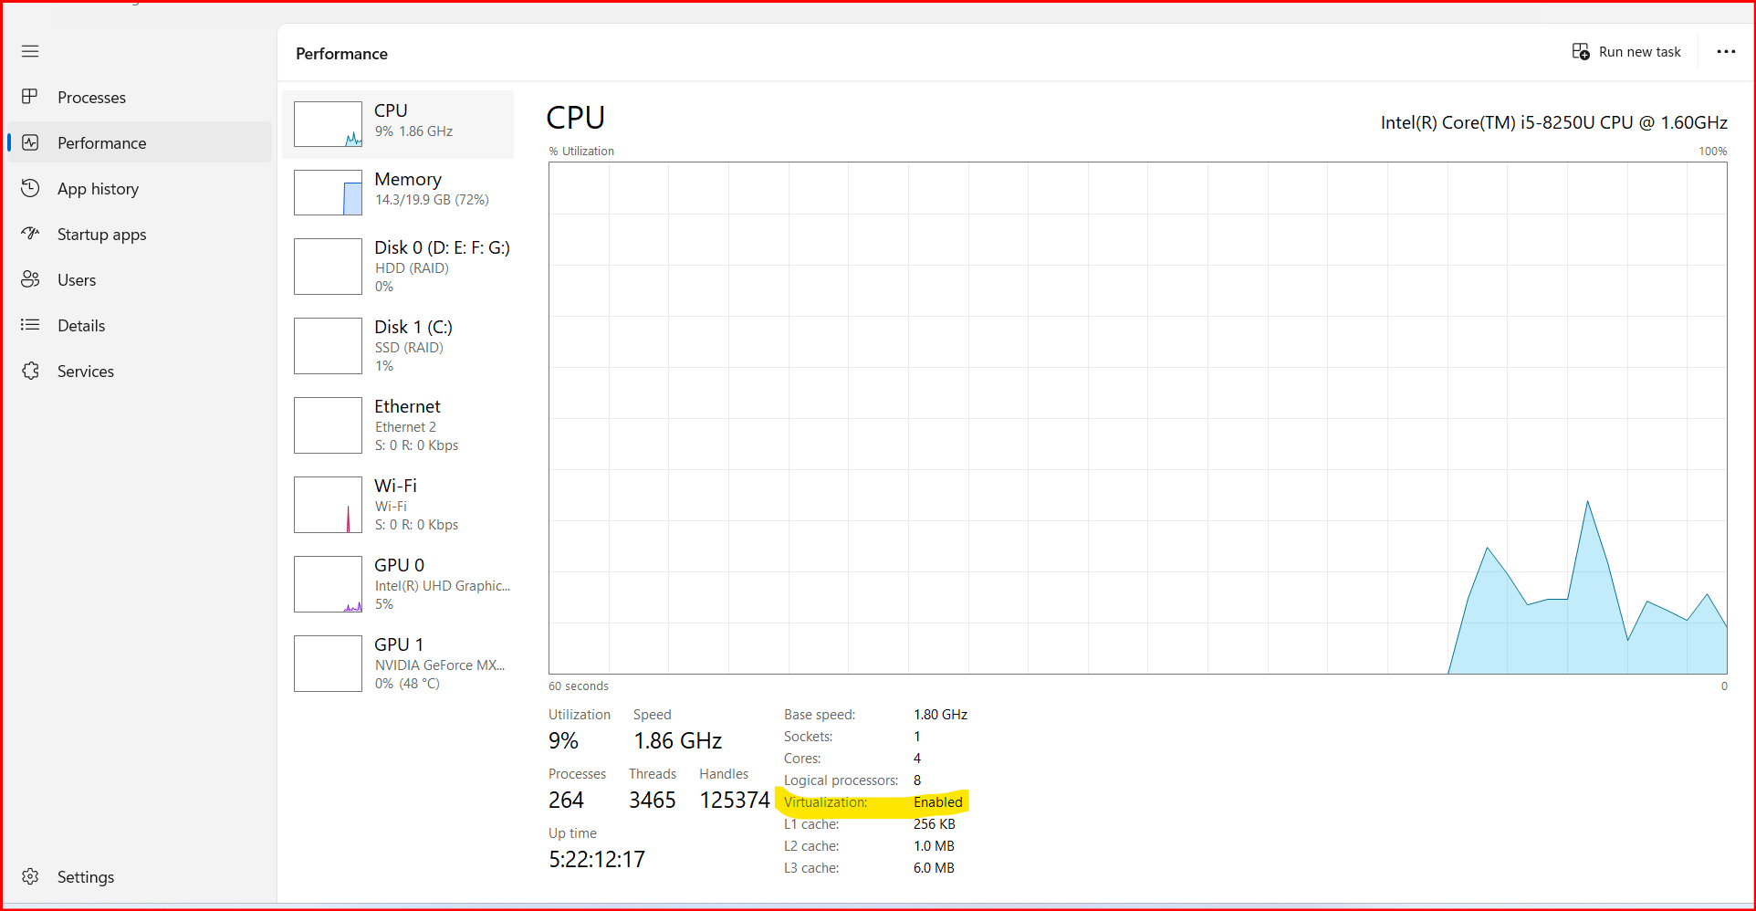
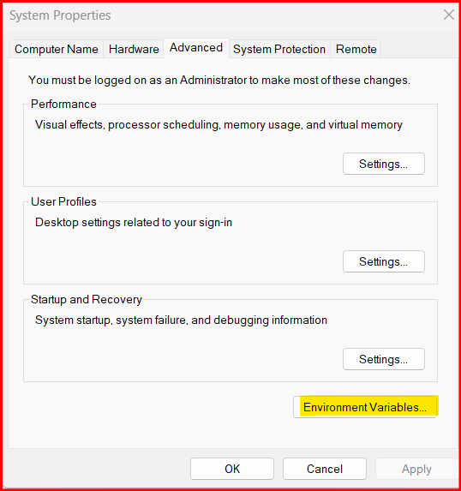
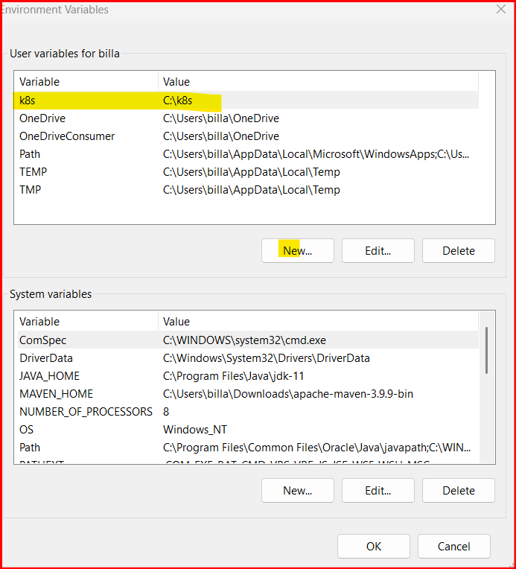

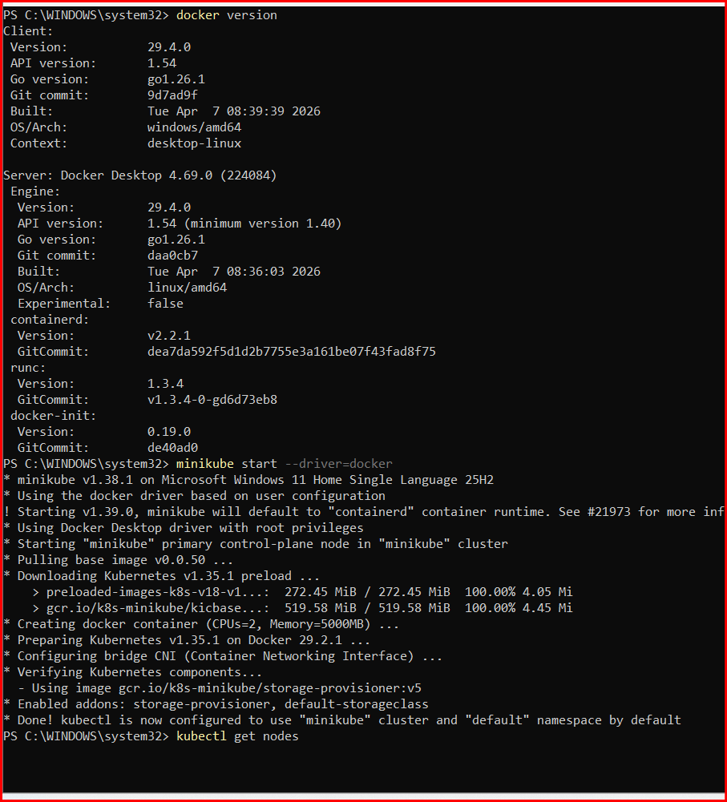

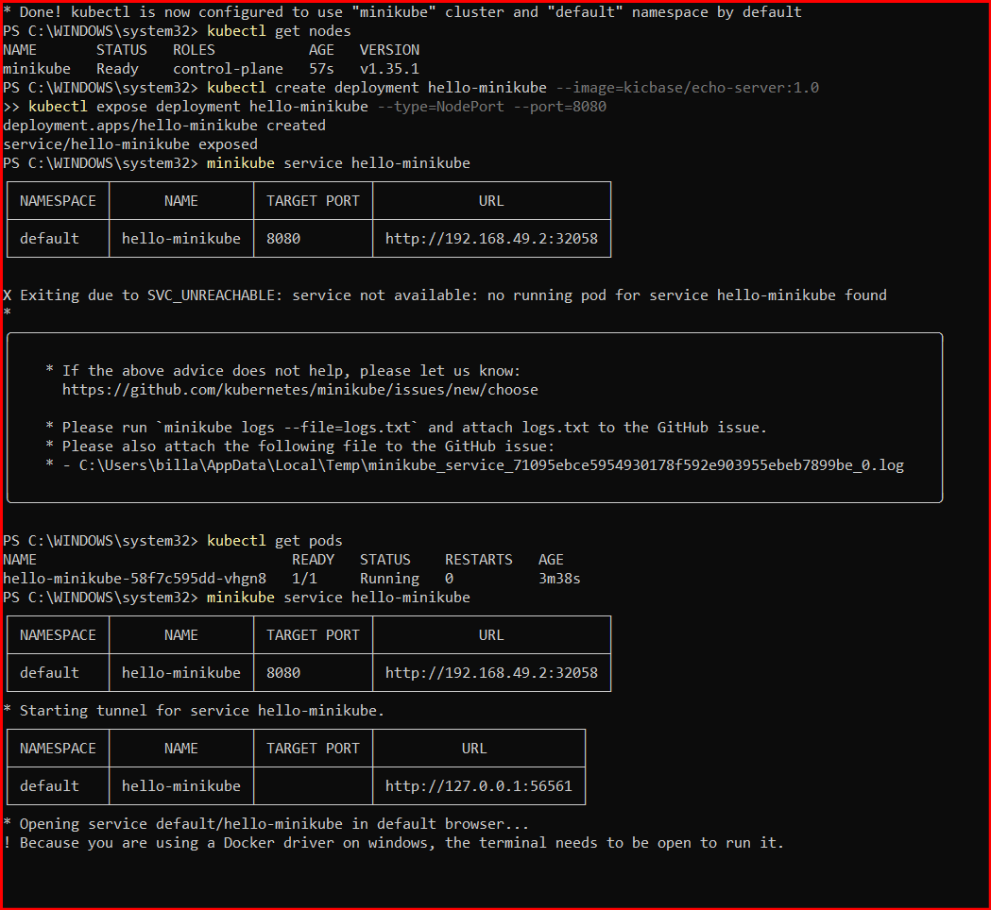

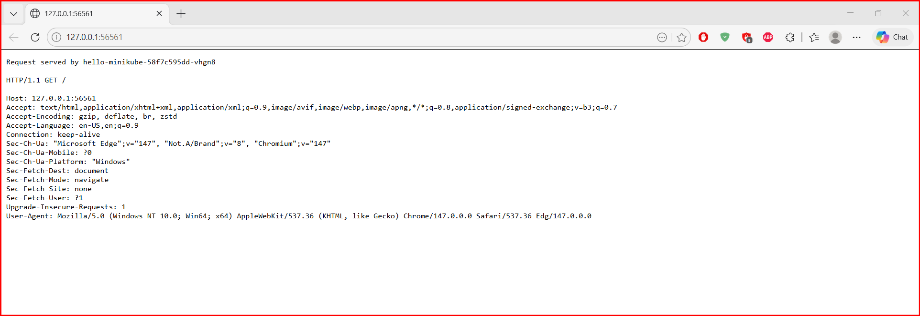

- Setup k8s master and two worker nodes on ubuntu.
🔹 Step 1: Launch EC2 Instances (3 Ubuntu Servers)
You launched:
• k8s-master
• worker-01
• worker-02
Configuration:
• Ubuntu 24.04 LTS
• Same VPC
• Same Security Group
• Multiple AZs
• C7I LARGE
• 20GB storage
• On all nodes sudo swapoff –a

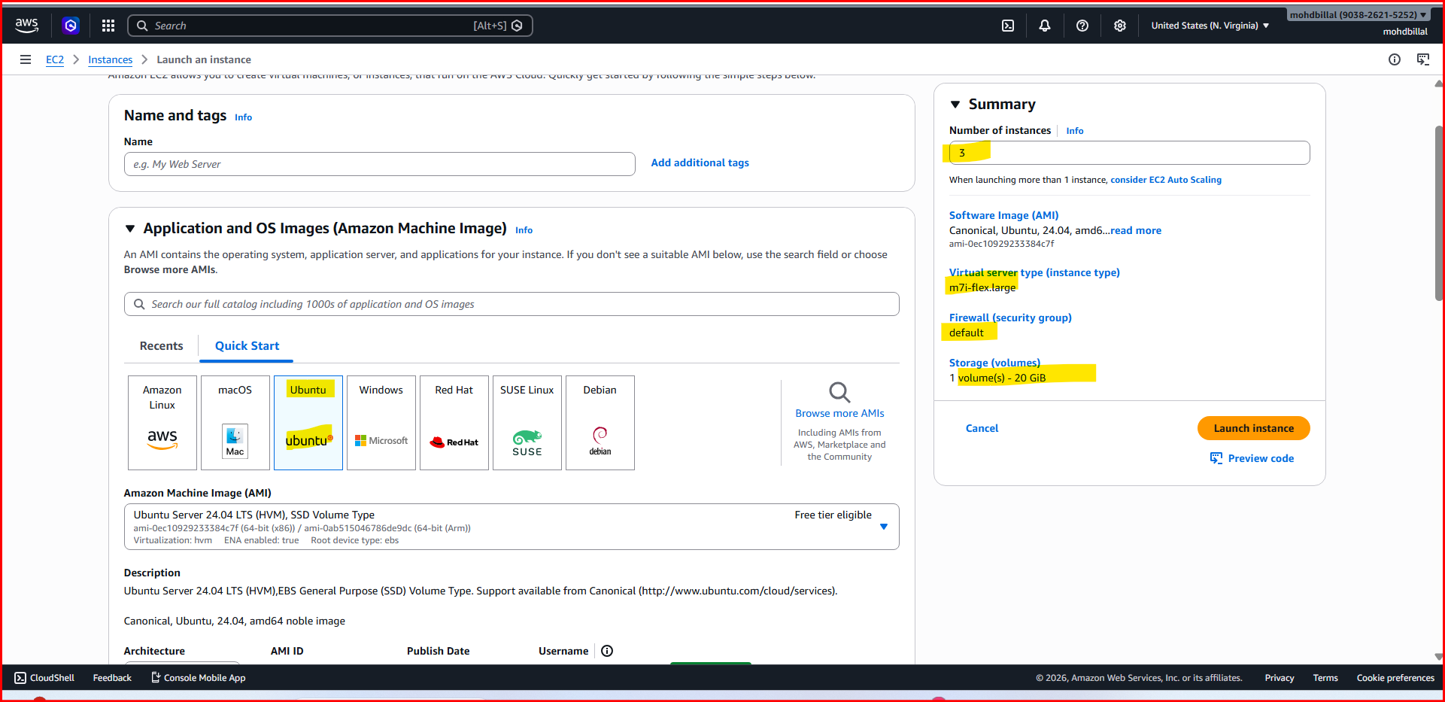
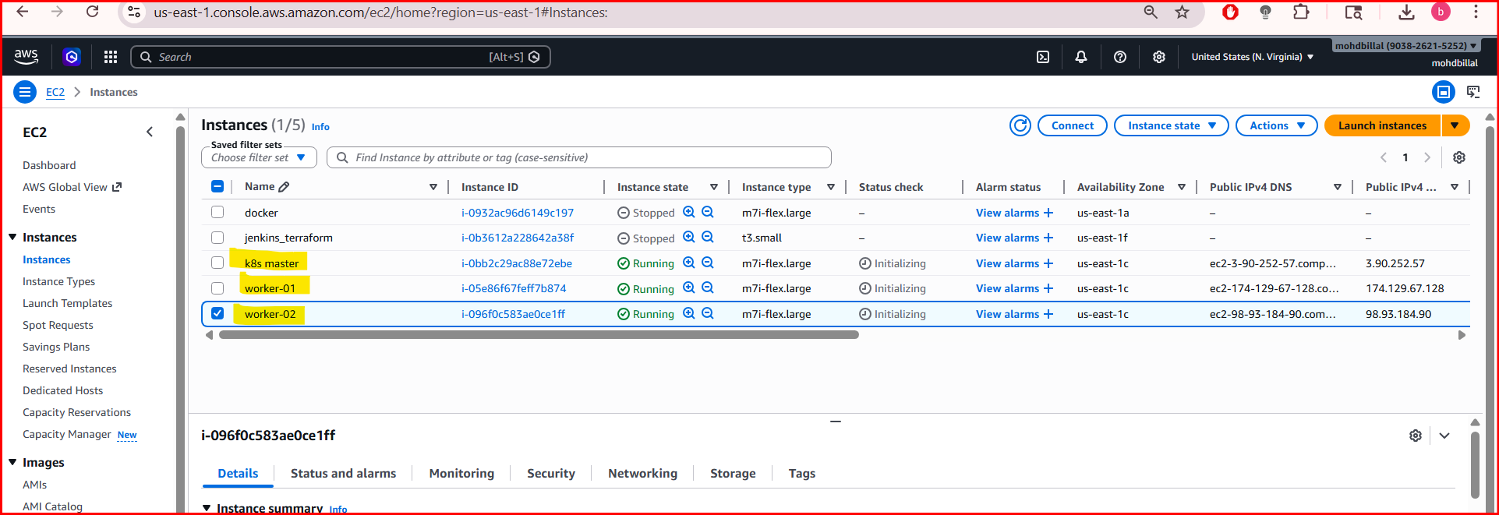

🔹 Step 2: Configure Hostnames (All Nodes)
On Master:
sudo hostnamectl set-hostname k8s-master
On Worker-01:
sudo hostnamectl set-hostname worker01
On Worker-02:
sudo hostnamectl set-hostname worker02

🔹 Step 3: Update /etc/hosts (All Nodes)
added private IP mappings for internal communication.
Example:
sudo vi/etc/hosts
Added:
172.31.21.107 k8s-master
172.31.16.174 worker01
172.31.16.196 worker02
192.168.0.110 localhost
Step 4: Disable Swap (All Nodes)
sudo swapoff -a
free -h
To make permanent:
sudo sed -i '/ swap / s/^/#/' /etc/fstab

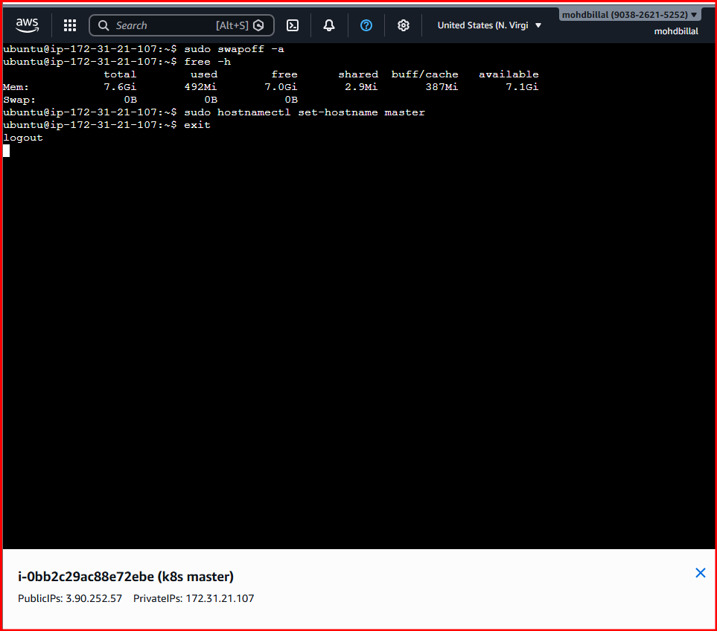

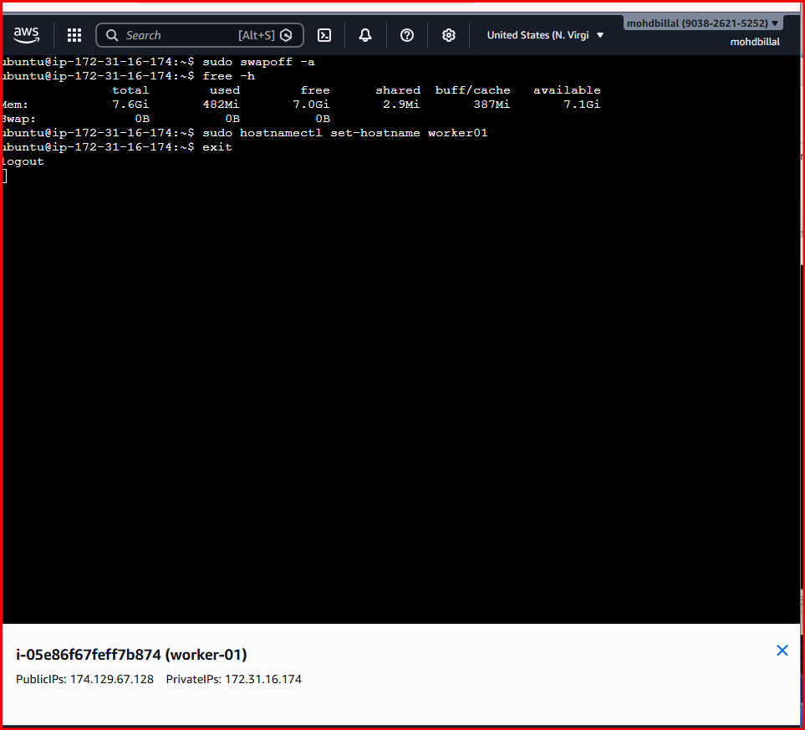

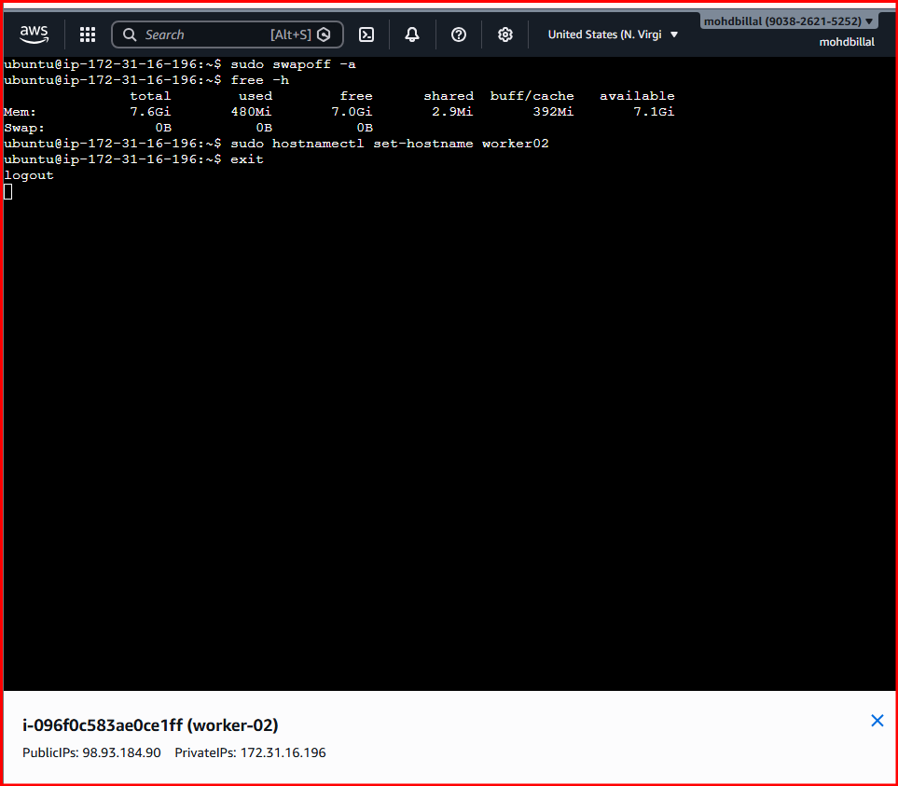

- Onces you logout from the ec2 terminal try to open different terminal like gitbash as some commands are not working in the ec2 terminal.

- Enter private IP of the 3 EC2 one master and two workers, and localhost of the pc

- You can get Localhost ip of pc in the power shell by entering command ipconfig.
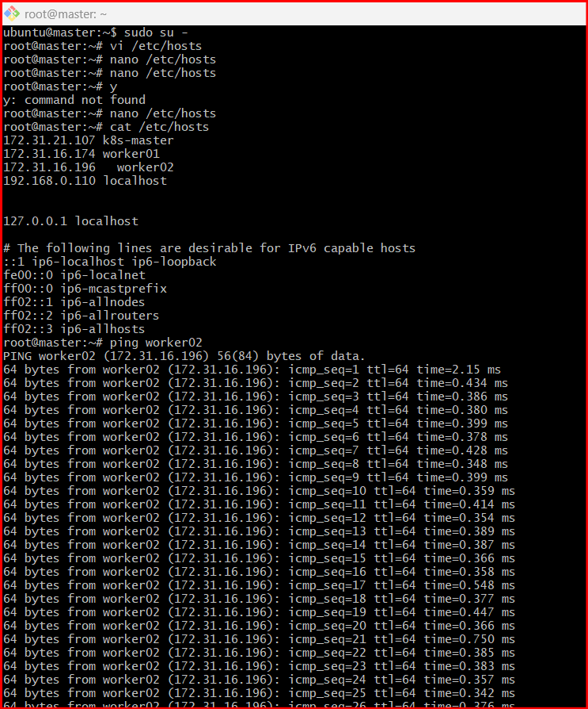

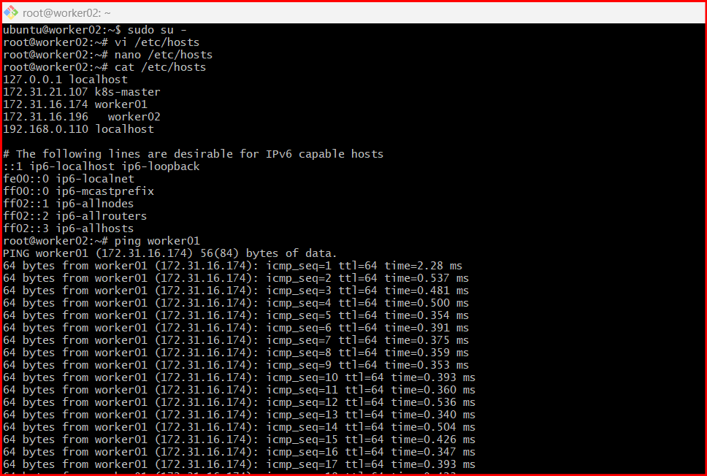

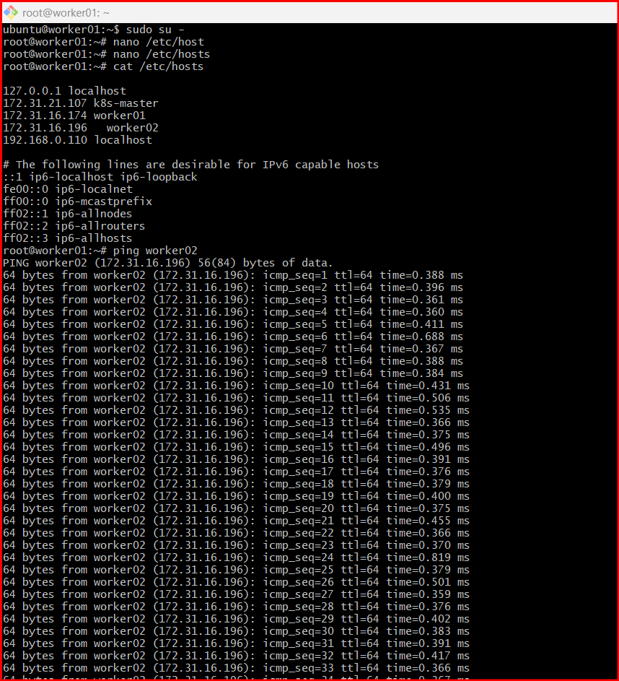

when all the nodes and master are connecting each other.

STEP 1: Do This on ALL NODES (Master + Workers)

1. Enable Kernel Modules
cat <<EOF | sudo tee /etc/modules-load.d/k8s.conf
overlay
br_netfilter
EOF
Load them:
sudo modprobe overlay
sudo modprobe br_netfilter

2. Set System Parameters
cat <<EOF | sudo tee /etc/sysctl.d/k8s.conf
net.bridge.bridge-nf-call-iptables = 1
net.bridge.bridge-nf-call-ip6tables = 1
net.ipv4.ip_forward = 1
EOF
Apply:
sudo sysctl --system

3.Install Kubernetes Tools
sudo apt update
sudo apt install -y apt-transport-https ca-certificates curl gpg
sudo mkdir -p /etc/apt/keyrings
Add repo:
curl -fsSL https://pkgs.k8s.io/core:/stable:/v1.29/deb/Release.key | \
sudo gpg --dearmor -o /etc/apt/keyrings/kubernetes-apt-keyring.gpg
echo "deb [signed-by=/etc/apt/keyrings/kubernetes-apt-keyring.gpg] \
https://pkgs.k8s.io/core:/stable:/v1.29/deb/ /" | \
sudo tee /etc/apt/sources.list.d/kubernetes.list
Install:
sudo apt update
sudo apt install -y kubelet kubeadm kubectl
sudo apt-mark hold kubelet kubeadm kubectl
Verify:
kubectl version --client
kubeadm version

4.Install Container Runtime (containerd)
sudo apt install -y containerd
Config:
sudo mkdir -p /etc/containerd
sudo containerd config default | sudo tee /etc/containerd/config.toml
Enable systemd:
sudo sed -i 's/SystemdCgroup = false/SystemdCgroup = true/' /etc/containerd/config.toml
Restart:
sudo systemctl restart containerd
sudo systemctl enable containerd

🔹 STEP 2: MASTER NODE ONLY

5. Initialize Cluster
sudo kubeadm init --pod-network-cidr=192.168.0.0/16

6. Configure kubectl
mkdir -p $HOME/.kube
sudo cp -i /etc/kubernetes/admin.conf $HOME/.kube/config
sudo chown $(id -u):$(id -g) $HOME/.kube/config

7.Check Nodes
kubectl get nodes
👉 Status will be:
NotReady (this is normal now)

🔹 STEP 3: INSTALL NETWORK (MASTER)

8.Install Calico CNI
kubectl apply -f https://raw.githubusercontent.com/projectcalico/calico/v3.26.1/manifests/tigera-operator.yaml
curl -O https://raw.githubusercontent.com/projectcalico/calico/v3.26.1/manifests/custom-resources.yaml
kubectl apply -f custom-resources.yaml

9. Verify
kubectl get pods -A
👉 Wait until all pods are Running

🔹 STEP 4: ADD WORKERS

🔟 Get Join Command (on Master)
kubeadm token create --print-join-command
👉 Example output:
kubeadm join 172.31.37.113:6443 --token xxxx \
--discovery-token-ca-cert-hash sha256:xxxx

11 Run on Worker-01 & Worker-02
sudo kubeadm join 172.31.37.113:6443 \
--token <token> \
--discovery-token-ca-cert-hash sha256:<hash>

🔹 STEP 5: FINAL VERIFICATION

1️⃣2️⃣ Check Cluster (on Master)
kubectl get nodes
✅ Expected:
k8s-master Ready
worker01 Ready
worker02 Ready

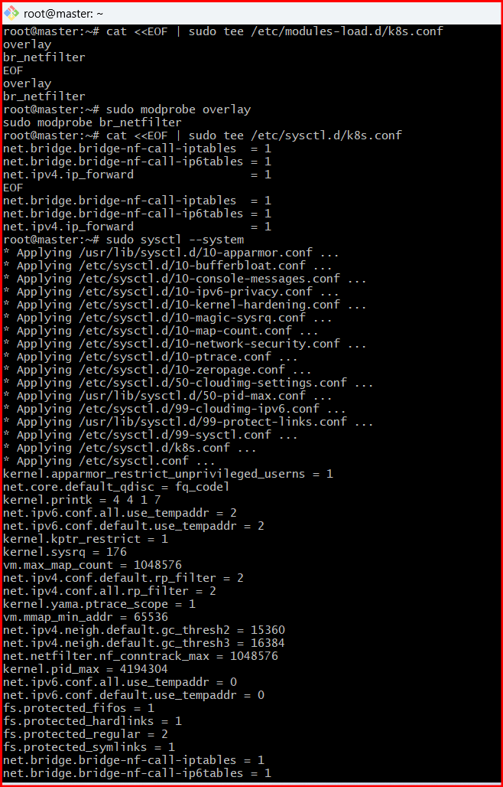

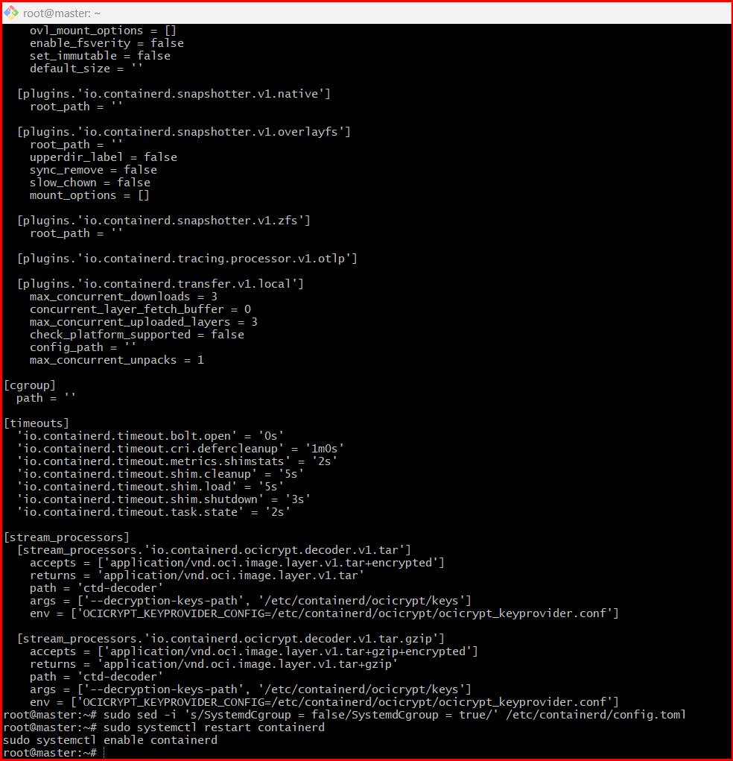

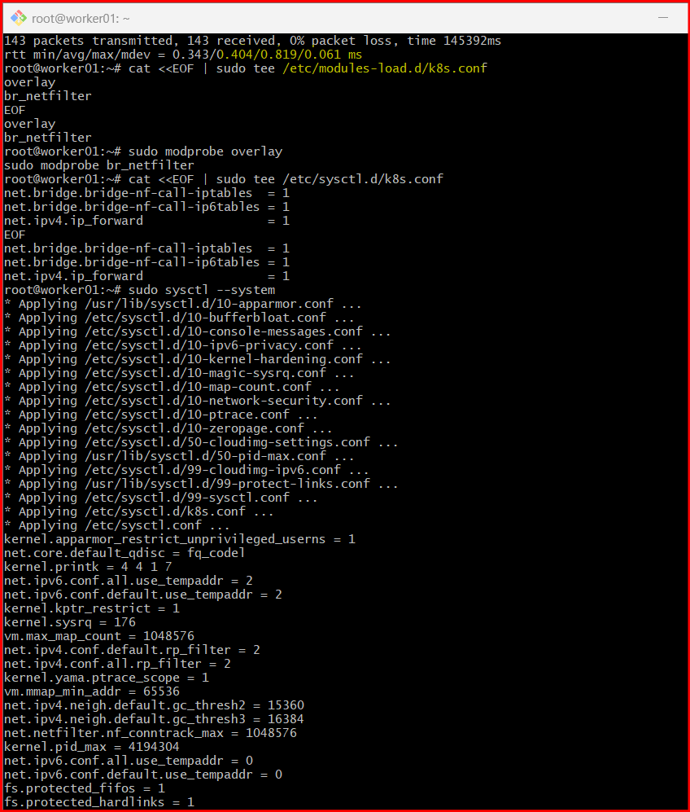

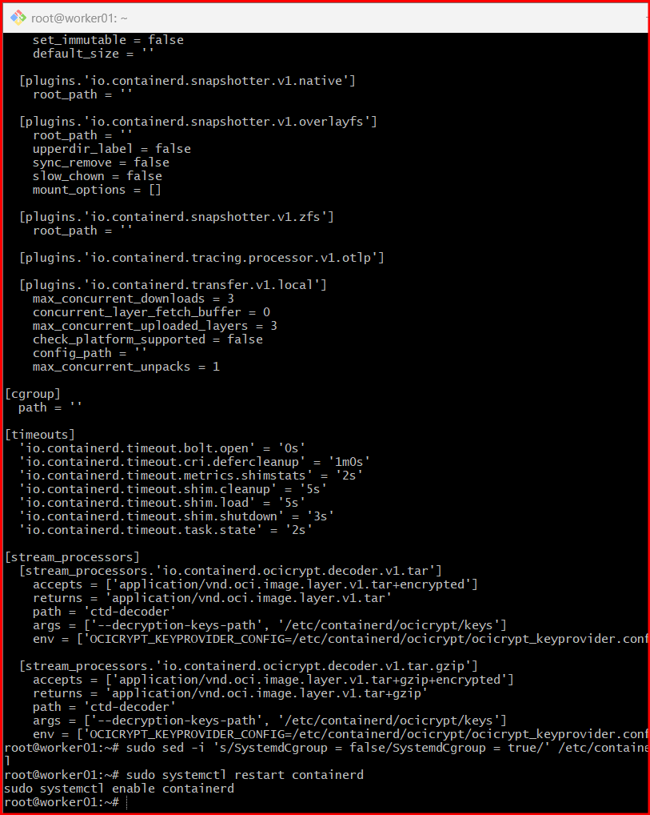

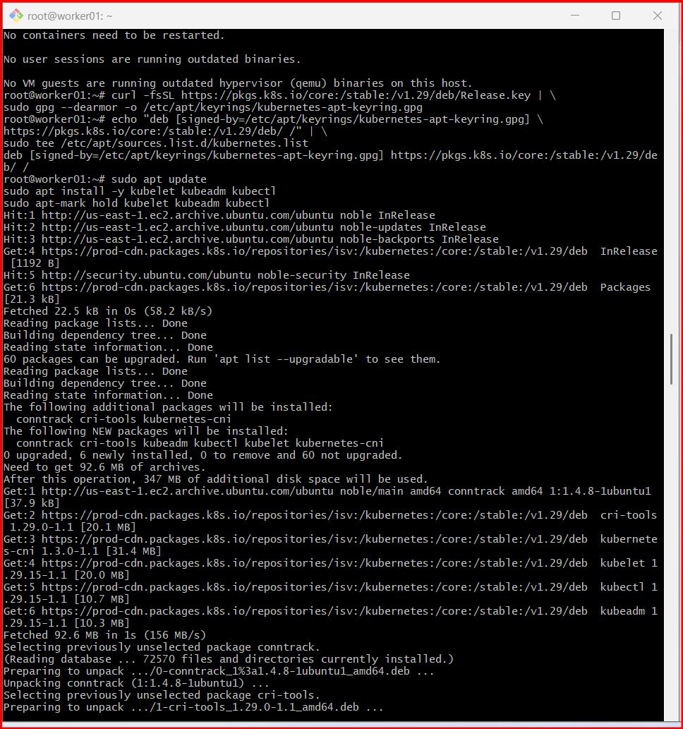

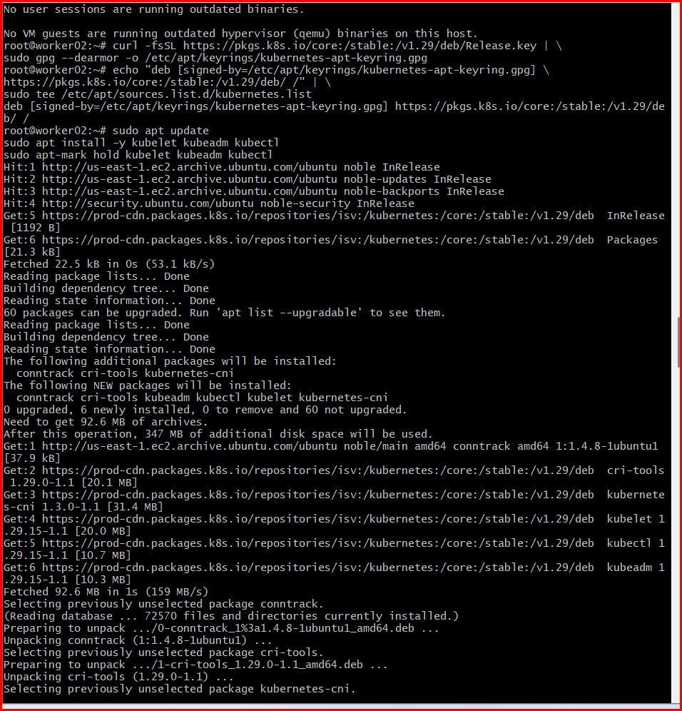

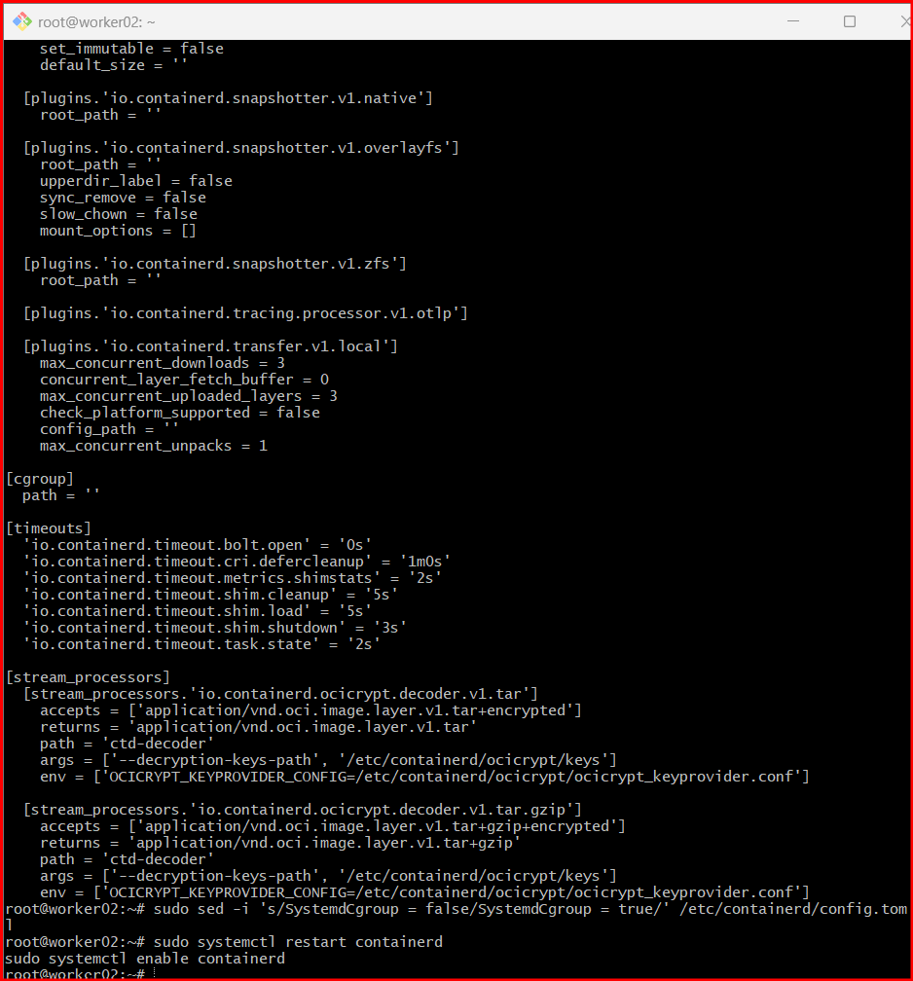

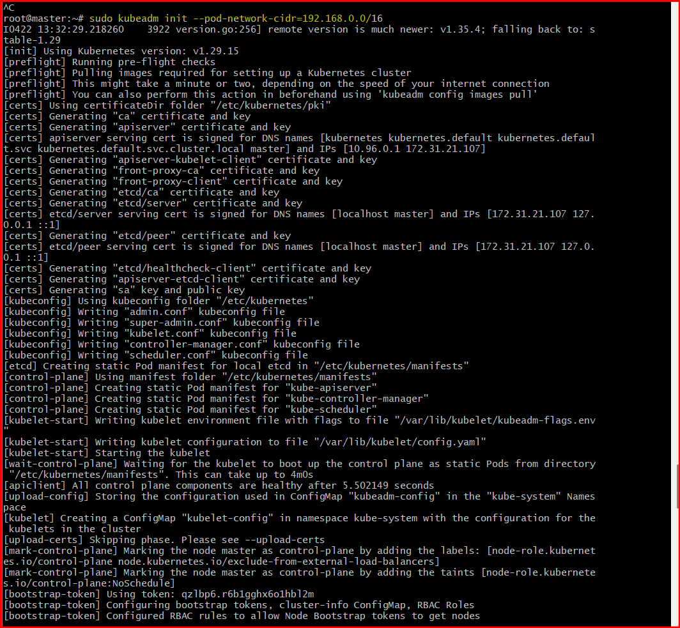

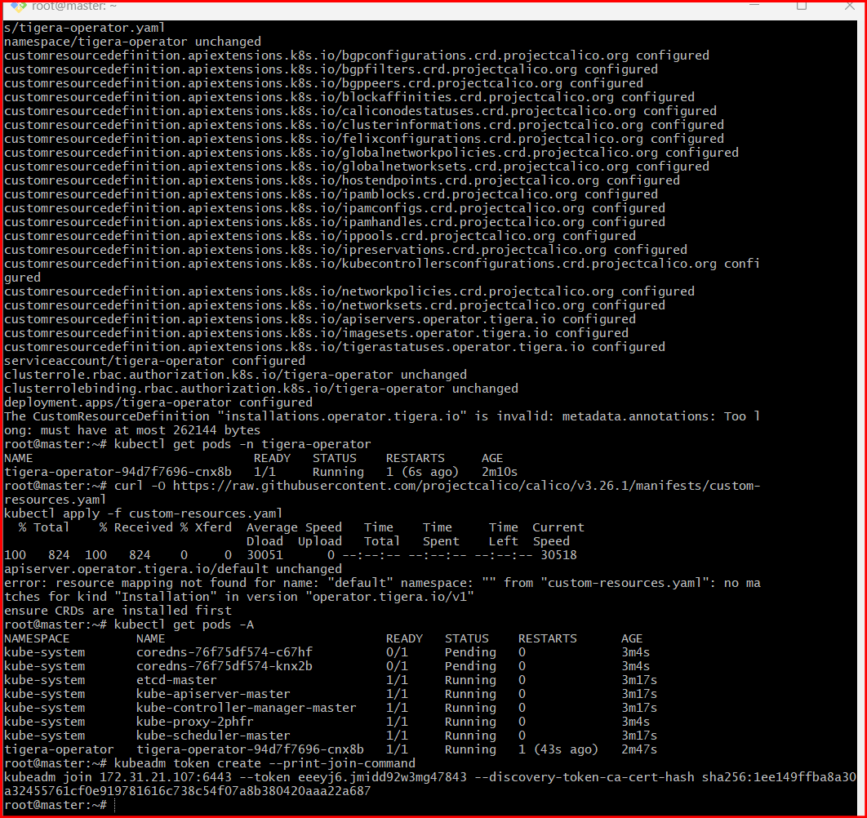

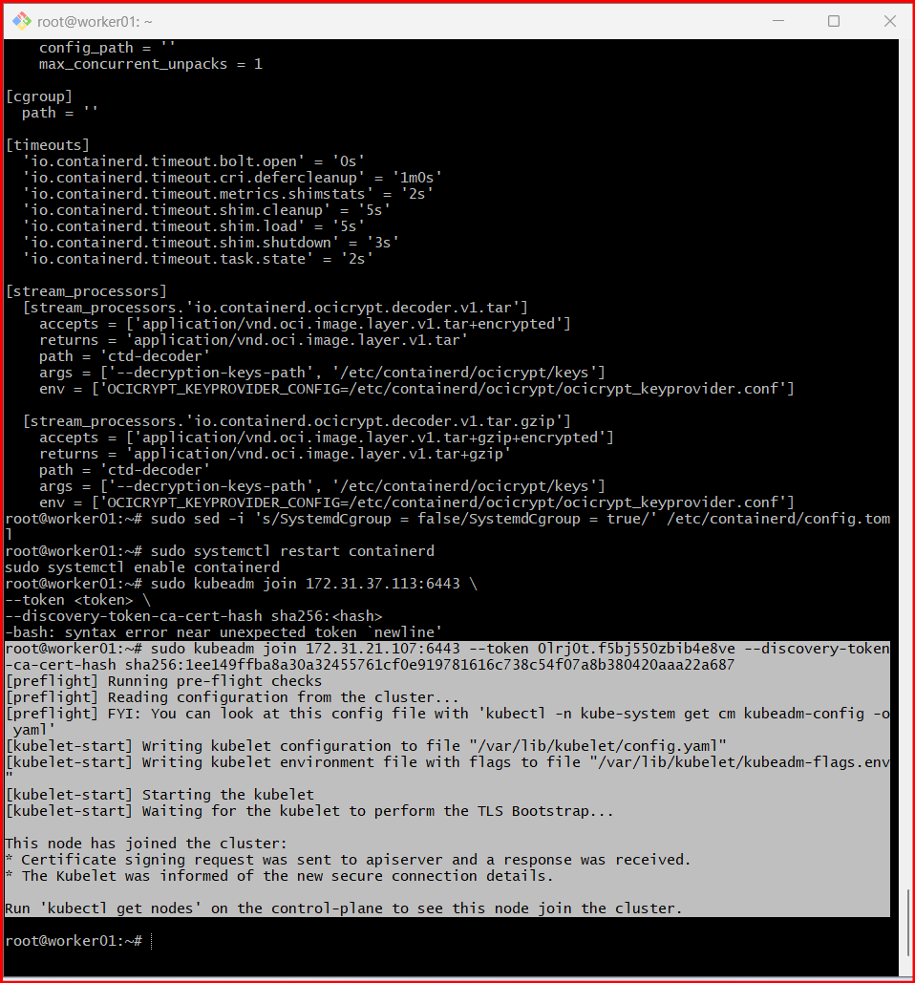

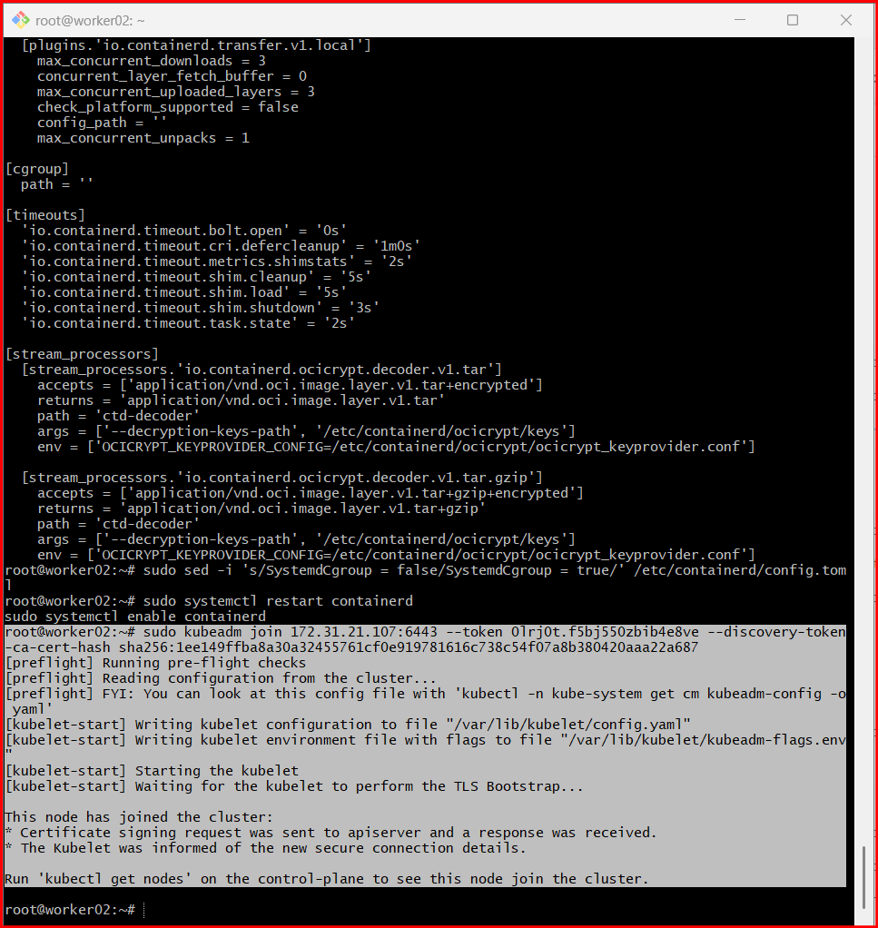

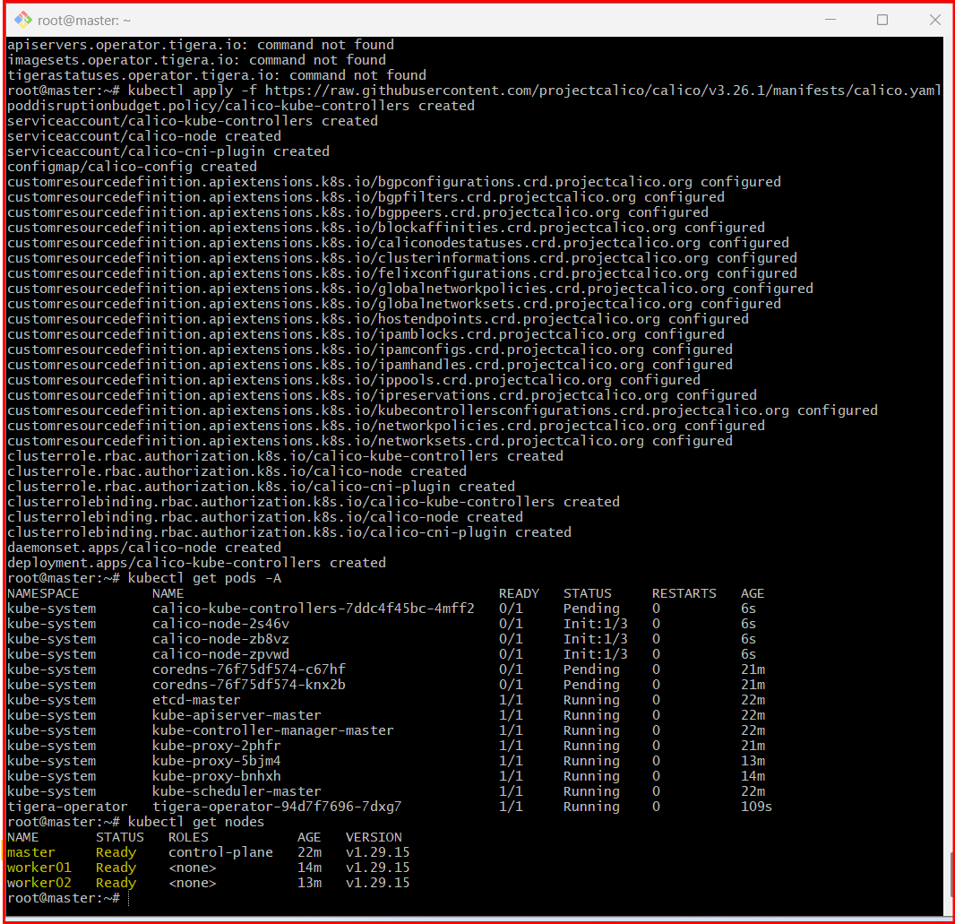

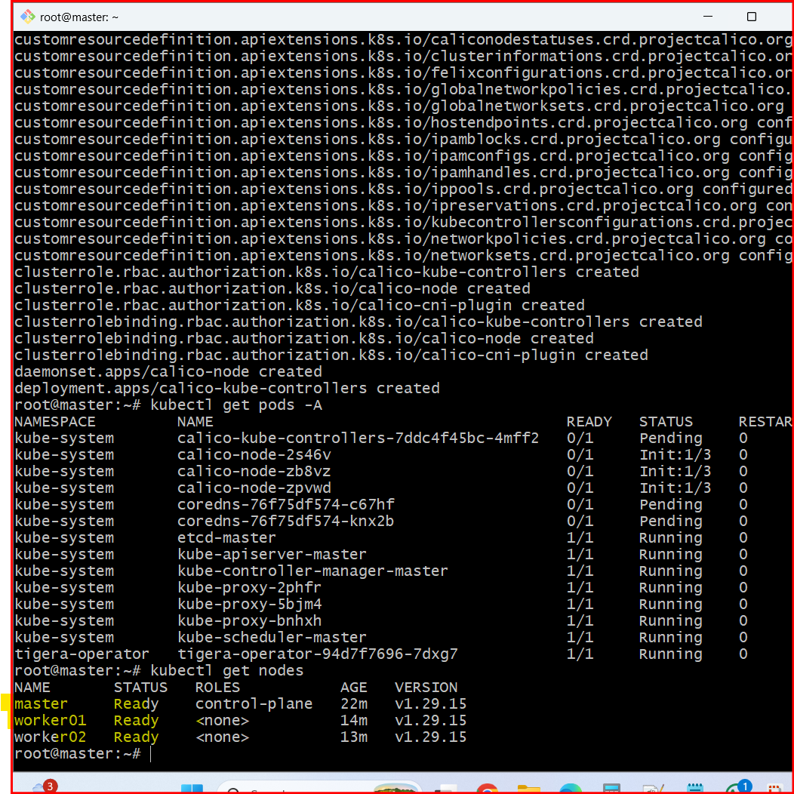

errors what I got with solutions.

deployment.apps/tigera-operator created The CustomResourceDefinition "installations.operator.tigera.io" is invalid: metadata.annotations: Too long: must have at most 262144 bytes root@master:~# kubectl get crds | grep tigera apiservers.operator.tigera.io 2026-04-22T13:53:04Z imagesets.operator.tigera.io 2026-04-22T13:53:04Z tigerastatuses.operator.tigera.io 2026-04-22T13:53:04Z
Show moreShow less
Great, now we hit the real root issue 🔥 — and this one is very specific.

🚨 Actual Error
The CustomResourceDefinition "installations.operator.tigera.io" is invalid:
metadata.annotations: Too long: must have at most 262144 bytes
👉 This means:
- Your Kubernetes API server rejected the CRD
- Because annotations size exceeded limit (256 KB)

🤔 Why this happens
This usually happens when:

❌ Causes
- Old kubectl / API mismatch
- Corrupted download / partial apply
- Known issue with some Calico versions + kubeadm setups

✅ BEST FIX (Use Stable Calico Manifest)
Instead of operator (which is failing), use direct Calico manifest ✅

🚀 SIMPLE & WORKING FIX

🔹 Step 1: Clean everything
kubectl delete -f custom-resources.yaml --ignore-not-found
kubectl delete -f https://raw.githubusercontent.com/projectcalico/calico/v3.26.1/manifests/tigera-operator.yaml --ignore-not-found
Delete CRDs:
kubectl get crds | grep tigera
Then delete all listed:
kubectl delete crd apiservers.operator.tigera.io
kubectl delete crd imagesets.operator.tigera.io
kubectl delete crd tigerastatuses.operator.tigera.io

🔹 Step 2: Install Calico (DIRECT METHOD ✅)
👉 This avoids operator completely (recommended for kubeadm)
kubectl apply -f https://raw.githubusercontent.com/projectcalico/calico/v3.26.1/manifests/calico.yaml

🔍 Step 3: Verify
kubectl get pods -A

✅ Expected
calico-system calico-node-xxxxx Running
calico-system calico-kube-controllers-xxxx Running

⏳ Step 4: Wait 1–2 minutes
Then:
kubectl get nodes

🎯 FINAL OUTPUT
master Ready
worker01 Ready
worker02 Ready

3Q . Run one nginx pod.

Quick Command (Recommended)
- kubectl run nginx-pod --image=nginx --restart=Never

🔍 Verify the Pod
- kubectl get pods
- You should see something like:
- nginx-pod 1/1 Running 0 XXs

📄 Get More Details
- kubectl describe pod nginx-pod

🌐 (Optional) Access the Pod
- If you want to access it locally:
- kubectl port-forward nginx-pod 8080:80
- Now open in browser:
- http://localhost:8080

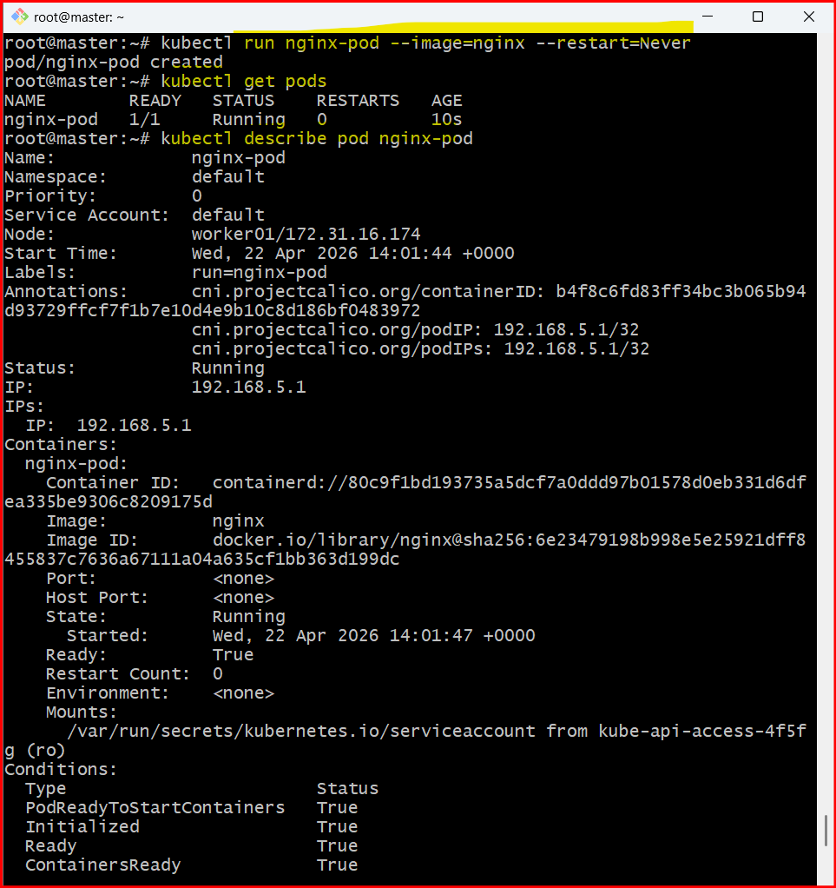

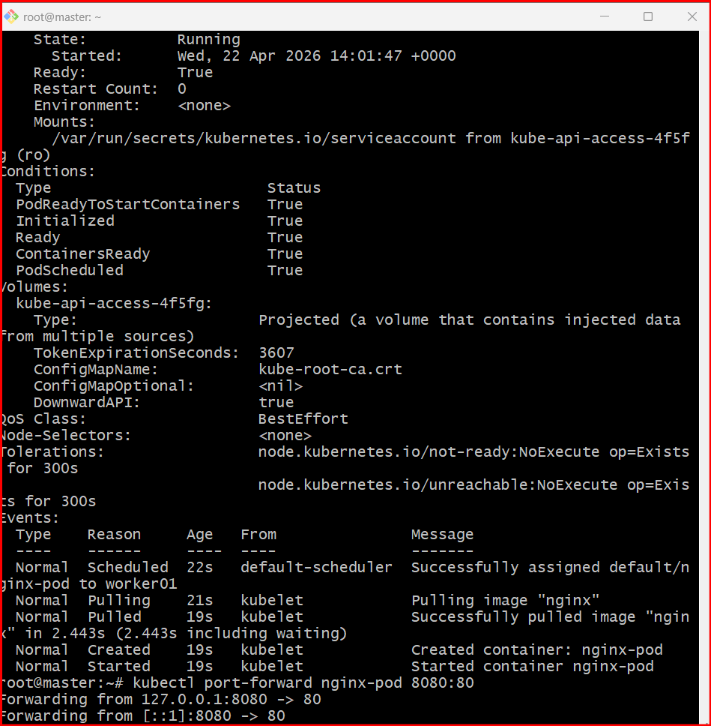

4Q. Mugup Master and slave components on k8s.
1. Control Plane (Master Node)
The control plane manages the entire Kubernetes cluster. It makes scheduling decisions and maintains the desired state.
Components:
1) kube-apiserver
- Entry point of the cluster
- All kubectl commands go through it
- Validates and processes API requests
- Communicates with etcd
2) etcd
- Key-value database
- Stores cluster state
- Stores:
  - Pods
  - Services
  - Secrets
  - ConfigMaps
  - Node information
3) kube-scheduler
- Assigns Pods to worker nodes
- Decides based on:
  - CPU and memory availability
  - Taints and tolerations
  - Node selectors and affinity rules
4) kube-controller-manager
Runs multiple controllers, such as:
- Node Controller
- ReplicaSet Controller
- Deployment Controller
- Job Controller
Ensures actual state matches desired state.

2. Worker Node (Slave Node)
Worker nodes run the application workloads.
Components:
1) kubelet
- Agent running on each worker node
- Receives instructions from control plane
- Ensures containers are running
- Reports node status to control plane
2) kube-proxy
- Handles networking rules
- Maintains iptables rules
- Enables communication between services and pods
3) Container Runtime
- containerd (recommended)
- Responsible for running containers
- Pulls images and starts containers

Architecture Flow
- User runs kubectl command
- Request goes to kube-apiserver
- Scheduler selects a worker node
- kubelet on that node creates the Pod
- Container runtime runs the container

In Your Current Cluster
Master node:
- Runs control plane components:
  - kube-apiserver
  - etcd
  - scheduler
  - controller-manager
Worker nodes:
- Run:
  - kubelet
  - kube-proxy
  - containerd
- Host application Pods

